SYSTEM DOCUMENT

Project: ECSE 211 Final Project (Team 08)
Task: To construct an autonomous robot capable of locating, grasping, carrying and placing an optical beacon, while navigating within an enclosed area populated with known obstacles placed at restricted locations within the enclosure.

Document Version Number: 03
Date: 28/11/2012
Author: Andrew Walker, Dan Crisan, Maxime Gregoire, Ammad Usman

This document is intended to identify and define the solution environment, i.e. the tools you can use and the basic components you have to construct a solution from. You need to identify the capabilities of all parts that you have – both software and hardware.

The goal of this document is to know everything you need to about the system to be used for implementing the solution to the design problem.

- TABLE OF CONTENTS
- System Model
- Hardware Available and Capabilities
- Software Available and Capabilities
- Compatibility
- Reusability
- Structures
- Methodology
- Tools
- Glossary

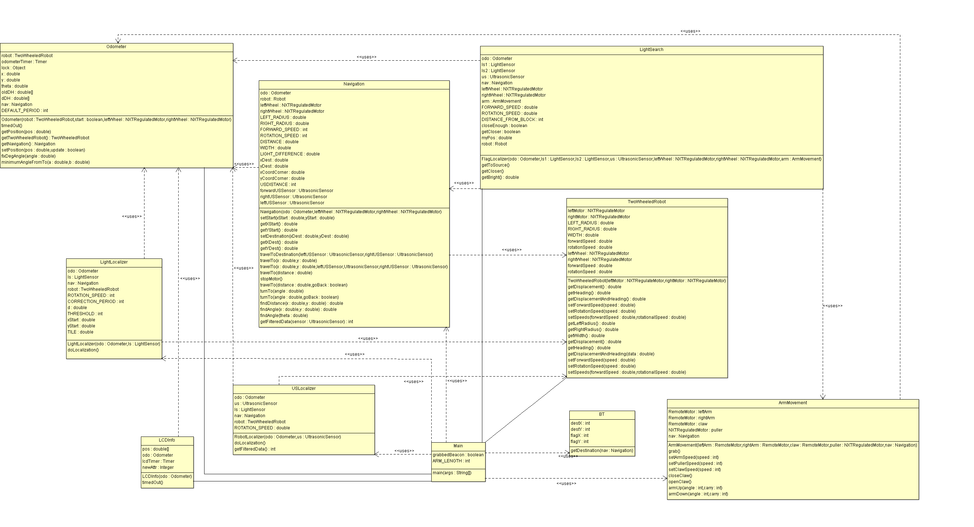
2.0 SYSTEM MODEL
(See UML diagram)
Basic Tasks
- The robot should be able to move around and avoid obstacles.
- The robot should be able to identify the beacon through the use of a light sensor.
- The robot should be able to pick up the beacon and put it somewhere else.
Sub Tasks
Localization
- The robot will be placed in a corner.
- The robot must be able to perform ultrasonic and light sensor localization.
- The heading must have little error.
Beacon detection
- The robot must be able to detect the beacon using the light sensor.
- The robot must follow a search pattern to get close enough to detect it.
Navigation
- The robot must be able to navigate to certain points on a field.
- The robot must be able to avoid obstacles as necessary.
Picking up and dropping beacon
- The robot should pick up the beacon when it is close enough to it.
- The robot should be able to take the beacon to another location and drop it.

Bluetooth
- The robot’s master brick should be able to take control of the slave brick and use all the sensors and motors attached to it.
- The robot must be able to communicate with the server and be able to store the information passed to it.

- HARDWARE AVAILABLE AND CAPABILITIES

Hardware Available
NXT brick
Technical specifications of the NXT Brick
- 32-bit ARM7 microcontroller @ 48 MHz (256 Kbytes FLASH, 64 Kbytes RAM)
- 8-bit AVR microcontroller (4 Kbytes FLASH, 512 Byte RAM)
- Bluetooth wireless communication (Bluetooth Class II V2.0 compliant)
- USB 1.1 full speed port (12 Mbit/s)
- 4 input ports, 6-wire cable digital platform
- 3 output ports, 6-wire cable digital platform
- 100 x 64 pixel LCD graphical display
- Power source: 6 AA batteries
Servo Motor
- Able to rotate a set number of degrees
- Can rotate under external forces.
- Made up of numerous gears.
Ultrasonic Sensor
- Measures distances between 0 and 255 cm, with a +/- 3 cm accuracy.
- Effective range of 6 to 180cm.
Light Sensor
- Measures a normalized light value between 0 and 1023, or in percentage form (0-100%).
- 2 modes: Active and Passive. Active mode is used for line detection (odometry). Passive mode is used for surrounding light detection.
Sound Sensor
- Measures sound intensity in decibels from 0 to 90 dB
- 2 modes: dB and dBA. dB mode measures straight decibels while dBA measures sound intensity based on human hearing range.
Touch Sensor
- Has a button that detects when it is being pressed.

Hardware constraints

- The Lego components are of limited usability due to their unyielding structure.
- The communication between bricks is not at all complex because there is memory limitation on the brick we are using.
- In hardware we are basically using two NXT bricks which would communicate between themselves. We would be using 3 ultrasonic sensors, 1 at the front and 2 at the sides for obstacle avoidance. We have 2 light sensors, one at the back for localization and one in front for beacon detection. We are using 6 motors.
- The robot is heavy so to support the base, the back of the robot is being supported by a ball (normal wheels don’t stand the weight) for 360º motion. The ball not always provides a smooth movement because of particles attached to the floor.

- SOFTWARE AVAILABLE AND CAPABILITIES

Eclipse offers some advantages over a simple text editor such as coloured syntax as well as making it easier to upload code to the robot (as opposed to uploading via the command prompt). We use Eclipse as our IDE as well as the leJOS library. There exist a large number of other libraries that are used by other languages, such as python, but as we used Java and leJOS in the labs, and, as a result, have more experience with it, it made more sense to continue using it for the purpose of our robot.

5.0 COMPATIBILITY
The version of leJOS that is being used in both NXT bricks is 0.9.1. The NXT bricks will communicate via Bluetooth (using the RemoteNXT library). The Bluetooth communication between the two is expected to have a larger drain on the battery, but implementing it frees up two sensor ports.

6.0 REUSABILITY
We will try to reuse and implement, after some manipulation, a number of the classes we had developed throughout the early part of the semester over the course of our labs (e.g. Odometer, Navigation, TwoWheeledRobot, LCDInfo, etc.).

7.0 STRUCTURES

With respect to the mechanical part, we will try to have a robot with a small footprint and should be fairly easy to replace batteries.

For the software aspect, we will keep the overall software design simple and used some basic object-oriented programming principles. This will keep the size of the code to a minimum, ensuring it can be used by the NXT brick.

8.0 METHODOLOGIES

We will divide the major tasks into manageable subtasks. Once we do this we can map the dependencies and determine the most important tasks necessary to completing the project.

Testing will be done after each individual component is programmed. Once it is ensured that the component works sufficiently well, we will integrate it into everything else done up to that point, ensuring it works together as a whole.

9.0 TOOLS
We will be using the three NXT kits provided to us at the beginning of the semester to build the robot (see mechanical design).

The Lego Digital Designer will be used to keep a record of the current version of the robot, should something happen to it that requires us to rebuild it. We will also use Eclipse and leJOS (See section 3). We will use Microsoft Excel during testing to store values and calculate errors and standard deviations as necessary.

